Spring 2016 MT2: Heaps and Balanced Trees
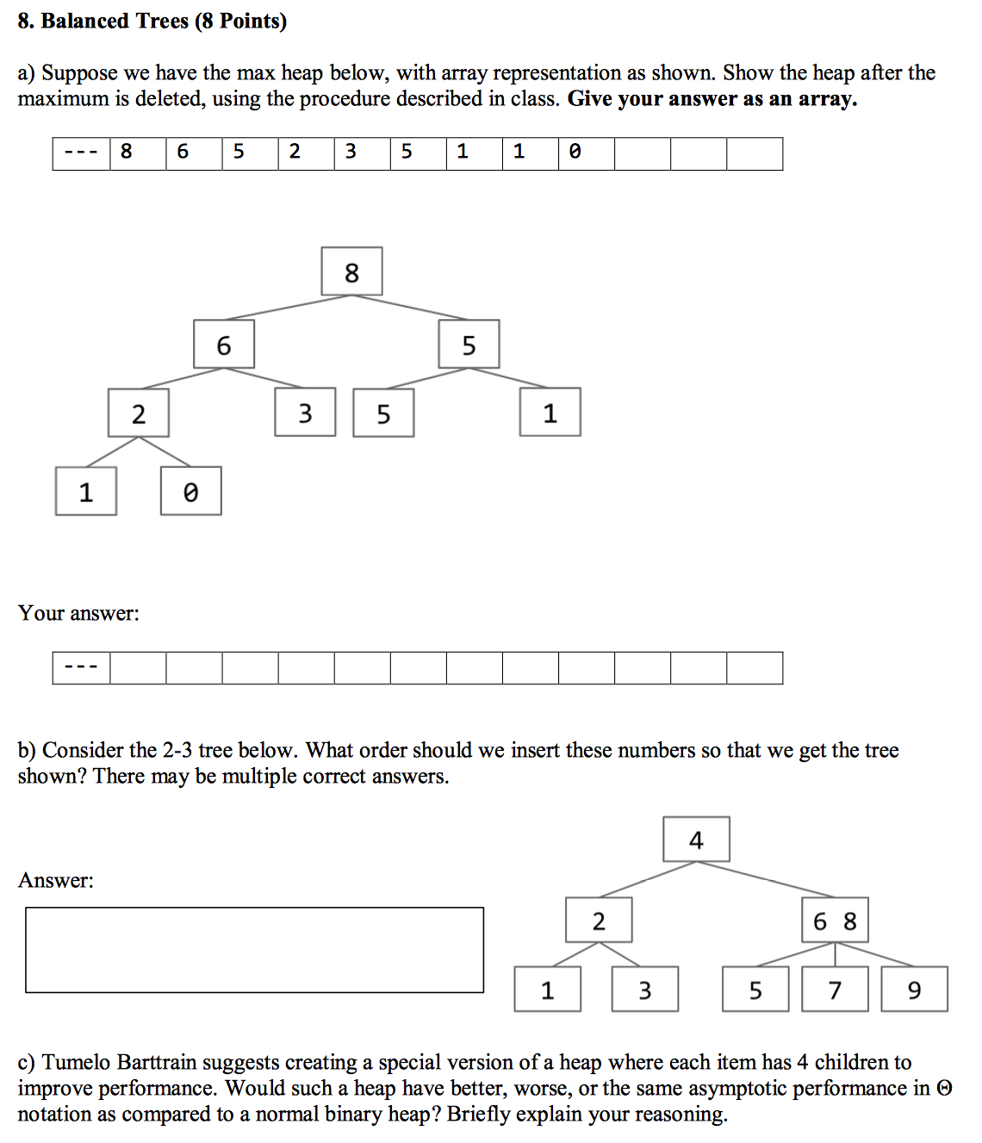

Spring 2016 Final: Heaps and Testing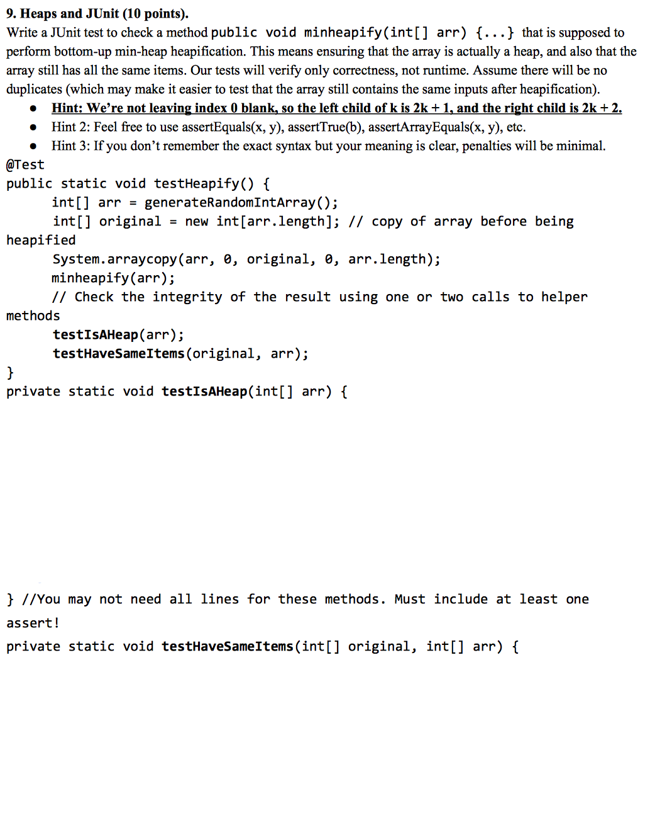
Spring 2016 Final: Sorting and Trees
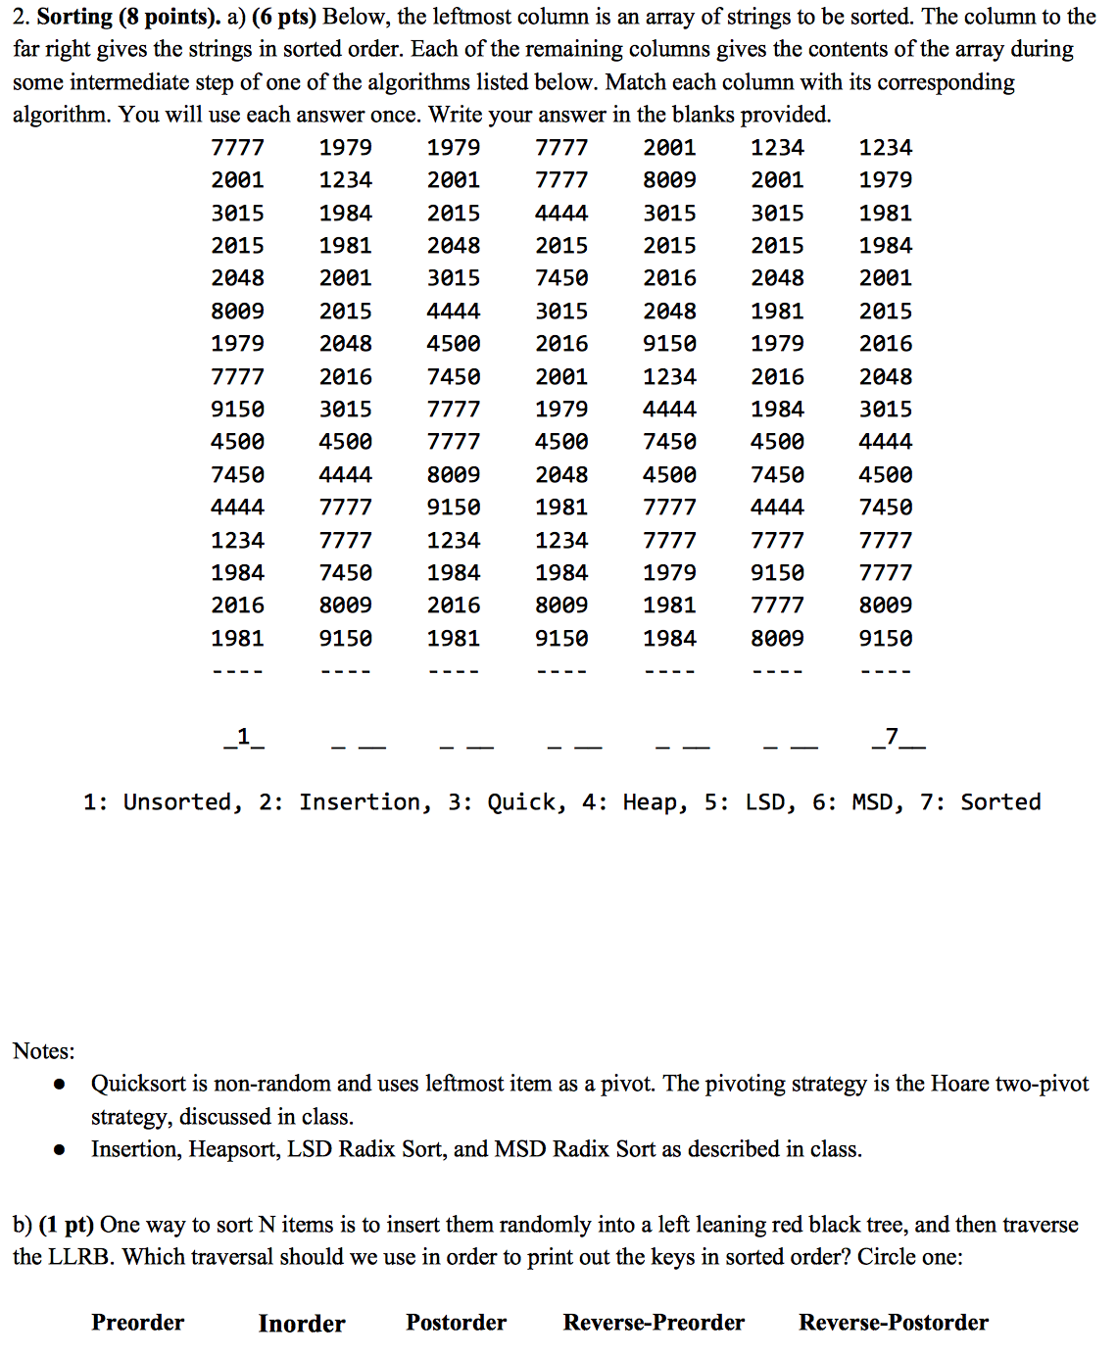
Spring 2015 Final: Trees, Sorts, Best and Worst 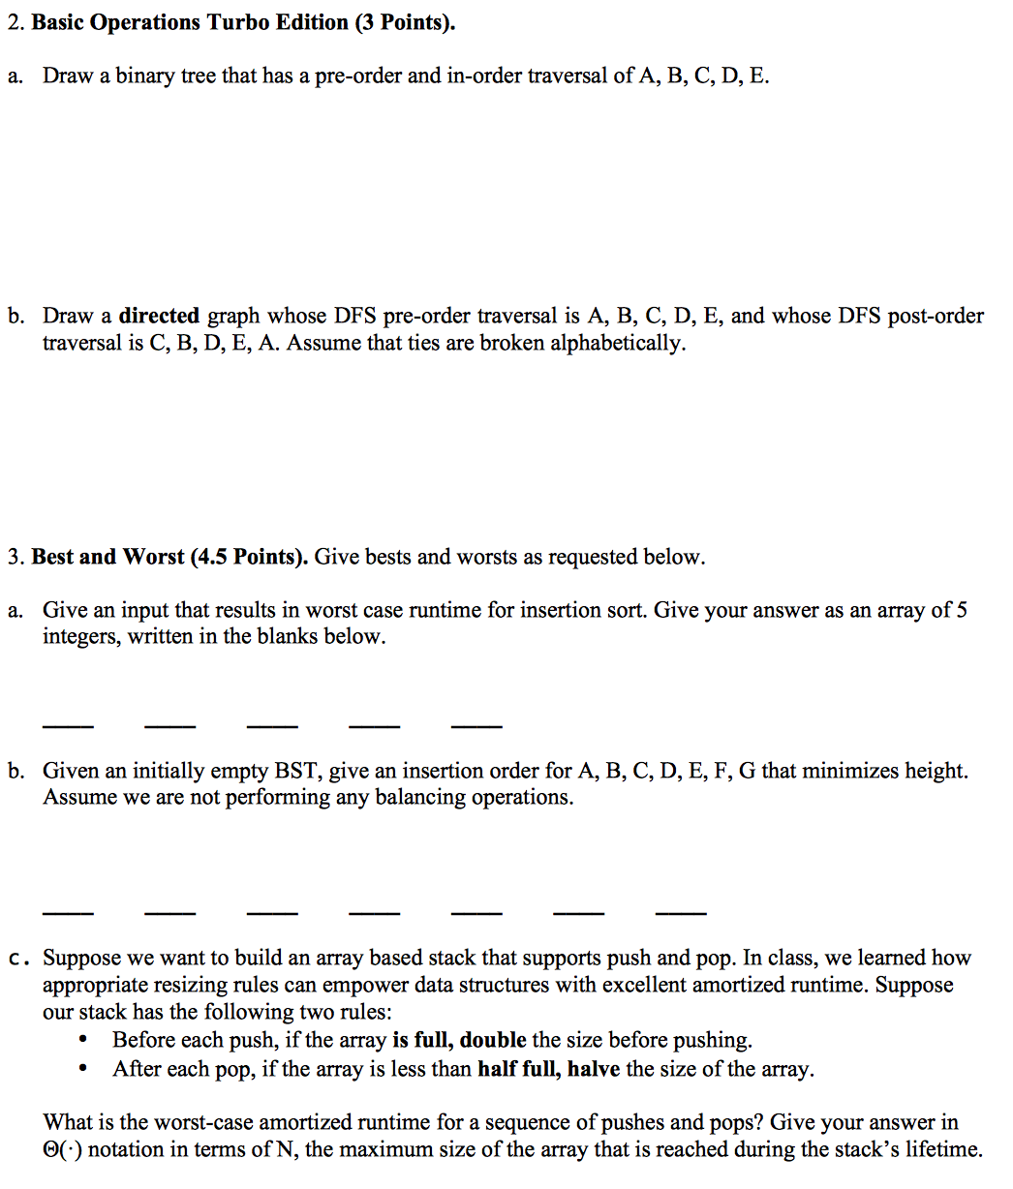

Spring 2015 Final: Data Structures and Algorithms
